Minutes form the Workshop on 21 July in Winterthur following the digital mediation session

Place : Grüze Innovation Lab Date : 29 July 2026 Participants: Alain, Valentino, Vicente, Zoé,
Document compiled from the audio tracks of the videos recorded on 21 July during the presentation of the various annotated collages by the consortium members present. To be reviewed and completed by the participants.

Between the railways (View point 1)

1. Summary
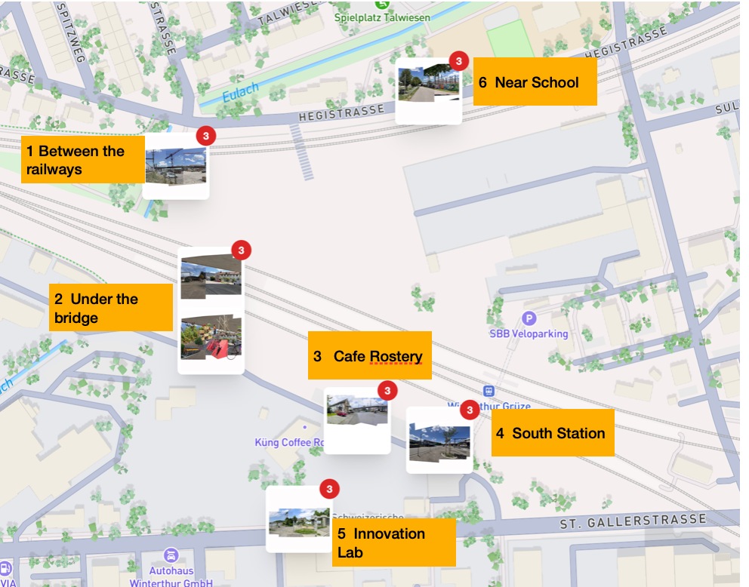
The purpose of this first presentation was to review and consolidate contributions for the development of the open space located between the railway lines. The conversation focused on ideas submitted by the community and cross-referenced them with currently planned initiatives.

2. Overview of Contributions
Zoé presented a comprehensive summary of contributions from the community, highlighting a strong desire to transform the area into a vibrant, multi-functional space. The key themes are as follows:
- Recreation and Open Spaces:
  - There is significant interest in creating large, activated public spaces, such as a multi-purpose green park modeled after the successful Euler Park.
  - Specific suggestions include play areas and sports facilities, with a football field being a popular request.
- Community and Culture:
  - A central theme was the desire for a dedicated place for residents to gather, meet their neighbors, and build community.
  - Contributions include hosting cultural events like music festivals and open-air cinemas.
  - To support these activities, the community requested amenities such as diverse food options and shaded areas for social gatherings.
- Housing:
  - A clear demand for affordable housing in the area was identified.
  - The community also expressed interest in community-driven housing models that feature shared spaces like courtyards and facilities like a repair café to foster neighborly interaction.
- Mobility and Safety:
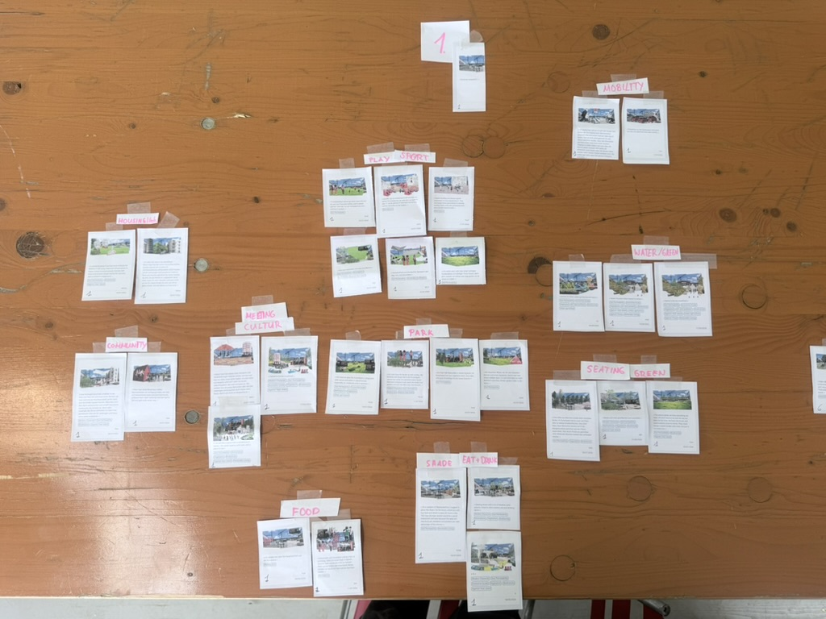
  - Accessibility was raised as a key concern, particularly for children and older adults.
  - A specific proposal was to install stairways from the new bridge to provide safe and convenient access to the space.

3. Confirmation of Planned Developments
Vicente confirmed that several of the community’s suggestions align with developments that are already planned for the area:
- Accessibility: The proposed stairways from the bridge down to the space are part of the current development plan.
- Sports Facilities: Sports facilities are planned, specifically noting the installation of paddle fields.
- Food and Beverage: Food and drink services are confirmed and will be provided by Gastro Herzog.

4. Key Takeaway
The discussion revealed a strong alignment between the community’s vision for a vibrant, accessible, and multi-use public space and the developer’s existing plans. Key community desires for recreation, social gathering, and amenities are being addressed, while the additional contributions for cultural programming and community-driven housing provide valuable insights for future planning phases.

_______________________________________________________________________
_______________________________________________________________________

Under-Bridge and in front of the coffee roaster (View point 2 and 3)

1. Summary
The contributions revealed a strong public desire to transform these areas from purely functional transit zones into vibrant, sheltered, and inclusive community hubs. Key themes emerging from the feedback include the need for social and commercial activities, recreational facilities, and significant aesthetic enhancements like greenery and art. The concept of “shelter” from the elements was identified as a primary asset of these locations.

2. Key Discussion Points & Public Feedback Synthesis
The team analyzed public input, grouping feedback into several key categories:
A. Desired Functions and Activities
- Commercial & Culinary: Valentino noted a demand for diverse commercial activities, including shopping opportunities, restaurants (some specifically for families), and food stalls. The idea of spaces for self-cooking (e.g., a grill place) was also mentioned.
- Social & Community (“Conviviality”): A major theme is the creation of spaces that foster a “conviviality atmosphere.” The public envisions areas for meeting new people, gathering with friends, and quiet solitary activities like reading.
- Recreation & Sport:
  - Alain highlighted a specific request from the skateboarding community for sheltered spaces, as rain and direct sun prevent them from using other outdoor areas.
  - Valentino and Vicente both mentioned the need for children’s play areas.
  - The concept of “collective learning” spaces, where informal classes (e.g., dancing, calligraphy) could take place, was introduced by Valentino.
- Mobility & Amenities:
  - The public reinterprets mobility infrastructure as a place to stay, not just pass through.
  - Specific requests include charging stations for electric vehicles and phones. As noted by Zoé and Valentino, this is a practical need, as people require something to do while waiting for their devices to charge.
  - Vicente added that improved bicycle infrastructure is also a key demand.
B. Environmental and Aesthetic Enhancements
- Aesthetics: Valentino pointed out a strong desire to combat the “gray” environment with color and artistic elements.
- Water Features: A recurring request for water elements like fountains or swimming areas was noted by both Valentino and Vicente, though Vicente also mentioned that some feedback questioned the realism of this.
- Green Spaces: A universal demand exists for more green areas, particularly near the train station. Alain clarified this is not just for color but for functional, biodiverse green spaces that provide shade and improve the atmosphere.
C. Governance, Inclusivity, and Safety
- Inclusivity Models: Valentino described a spectrum of opinions on governance:
  - Open & Inclusive: Spaces “for everyone,” where people can bring their own equipment (e.g., a ball).
  - Managed Space: A desire for amenities to be provided and secured on-site.
  - Inclusive “Club” Concept: Alain and Valentino discussed an interesting middle ground, a club based on participation and identity (giving time, being known) rather than financial exclusivity. This would foster community while remaining open.
- Demographics:
  - Age: Feedback emphasized the need for spaces catering to all ages, from children to the elderly. A key goal is to create opportunities for intergenerational meetings.
  - Gender: Zoé confirmed that gender was not a prominent topic in the feedback. Safety was seen as a universal concern for all.
- Safety: The team agreed that safety is a priority. The preferred approach is “safety by eye”, creating a vibrant, populated space that provides natural surveillance, rather than relying solely on technology.
D. Role of Technology
- Valentino observed a notable lack of demand for digital connectivity like public Wi-Fi. The feedback strongly prioritizes real, human interaction over digital interaction.
- The primary technology-related requests were for practical utilities, such as charging points for phones and vehicles, as mentioned by Zoé.

3. Key Takeaways for Project Co-Design
- Prioritize Shelter: The inherent protection from sun and rain is a core value proposition of under-bridge spaces and should be leveraged in the design for activities like skateboarding and social gatherings.
- Focus on Human-Centric Design: The primary goal should be to create quality, safe, and inviting spaces for people. Technology should be a supporting element (e.g., sensors, charging points) rather than the main feature.
- Embrace a Mix of Uses: The design should accommodate a blend of commercial, social, and recreational activities to create a vibrant, multi-purpose destination.
- Integrate Greenery and Art: Incorporating biodiversity, green spaces for shade, and artistic elements is critical to transforming the character of these concrete-heavy areas.
- Design for Inclusivity: The project should aim to create intergenerational spaces that are welcoming to all, while exploring flexible governance models like the “inclusive club” to foster a sense of community.

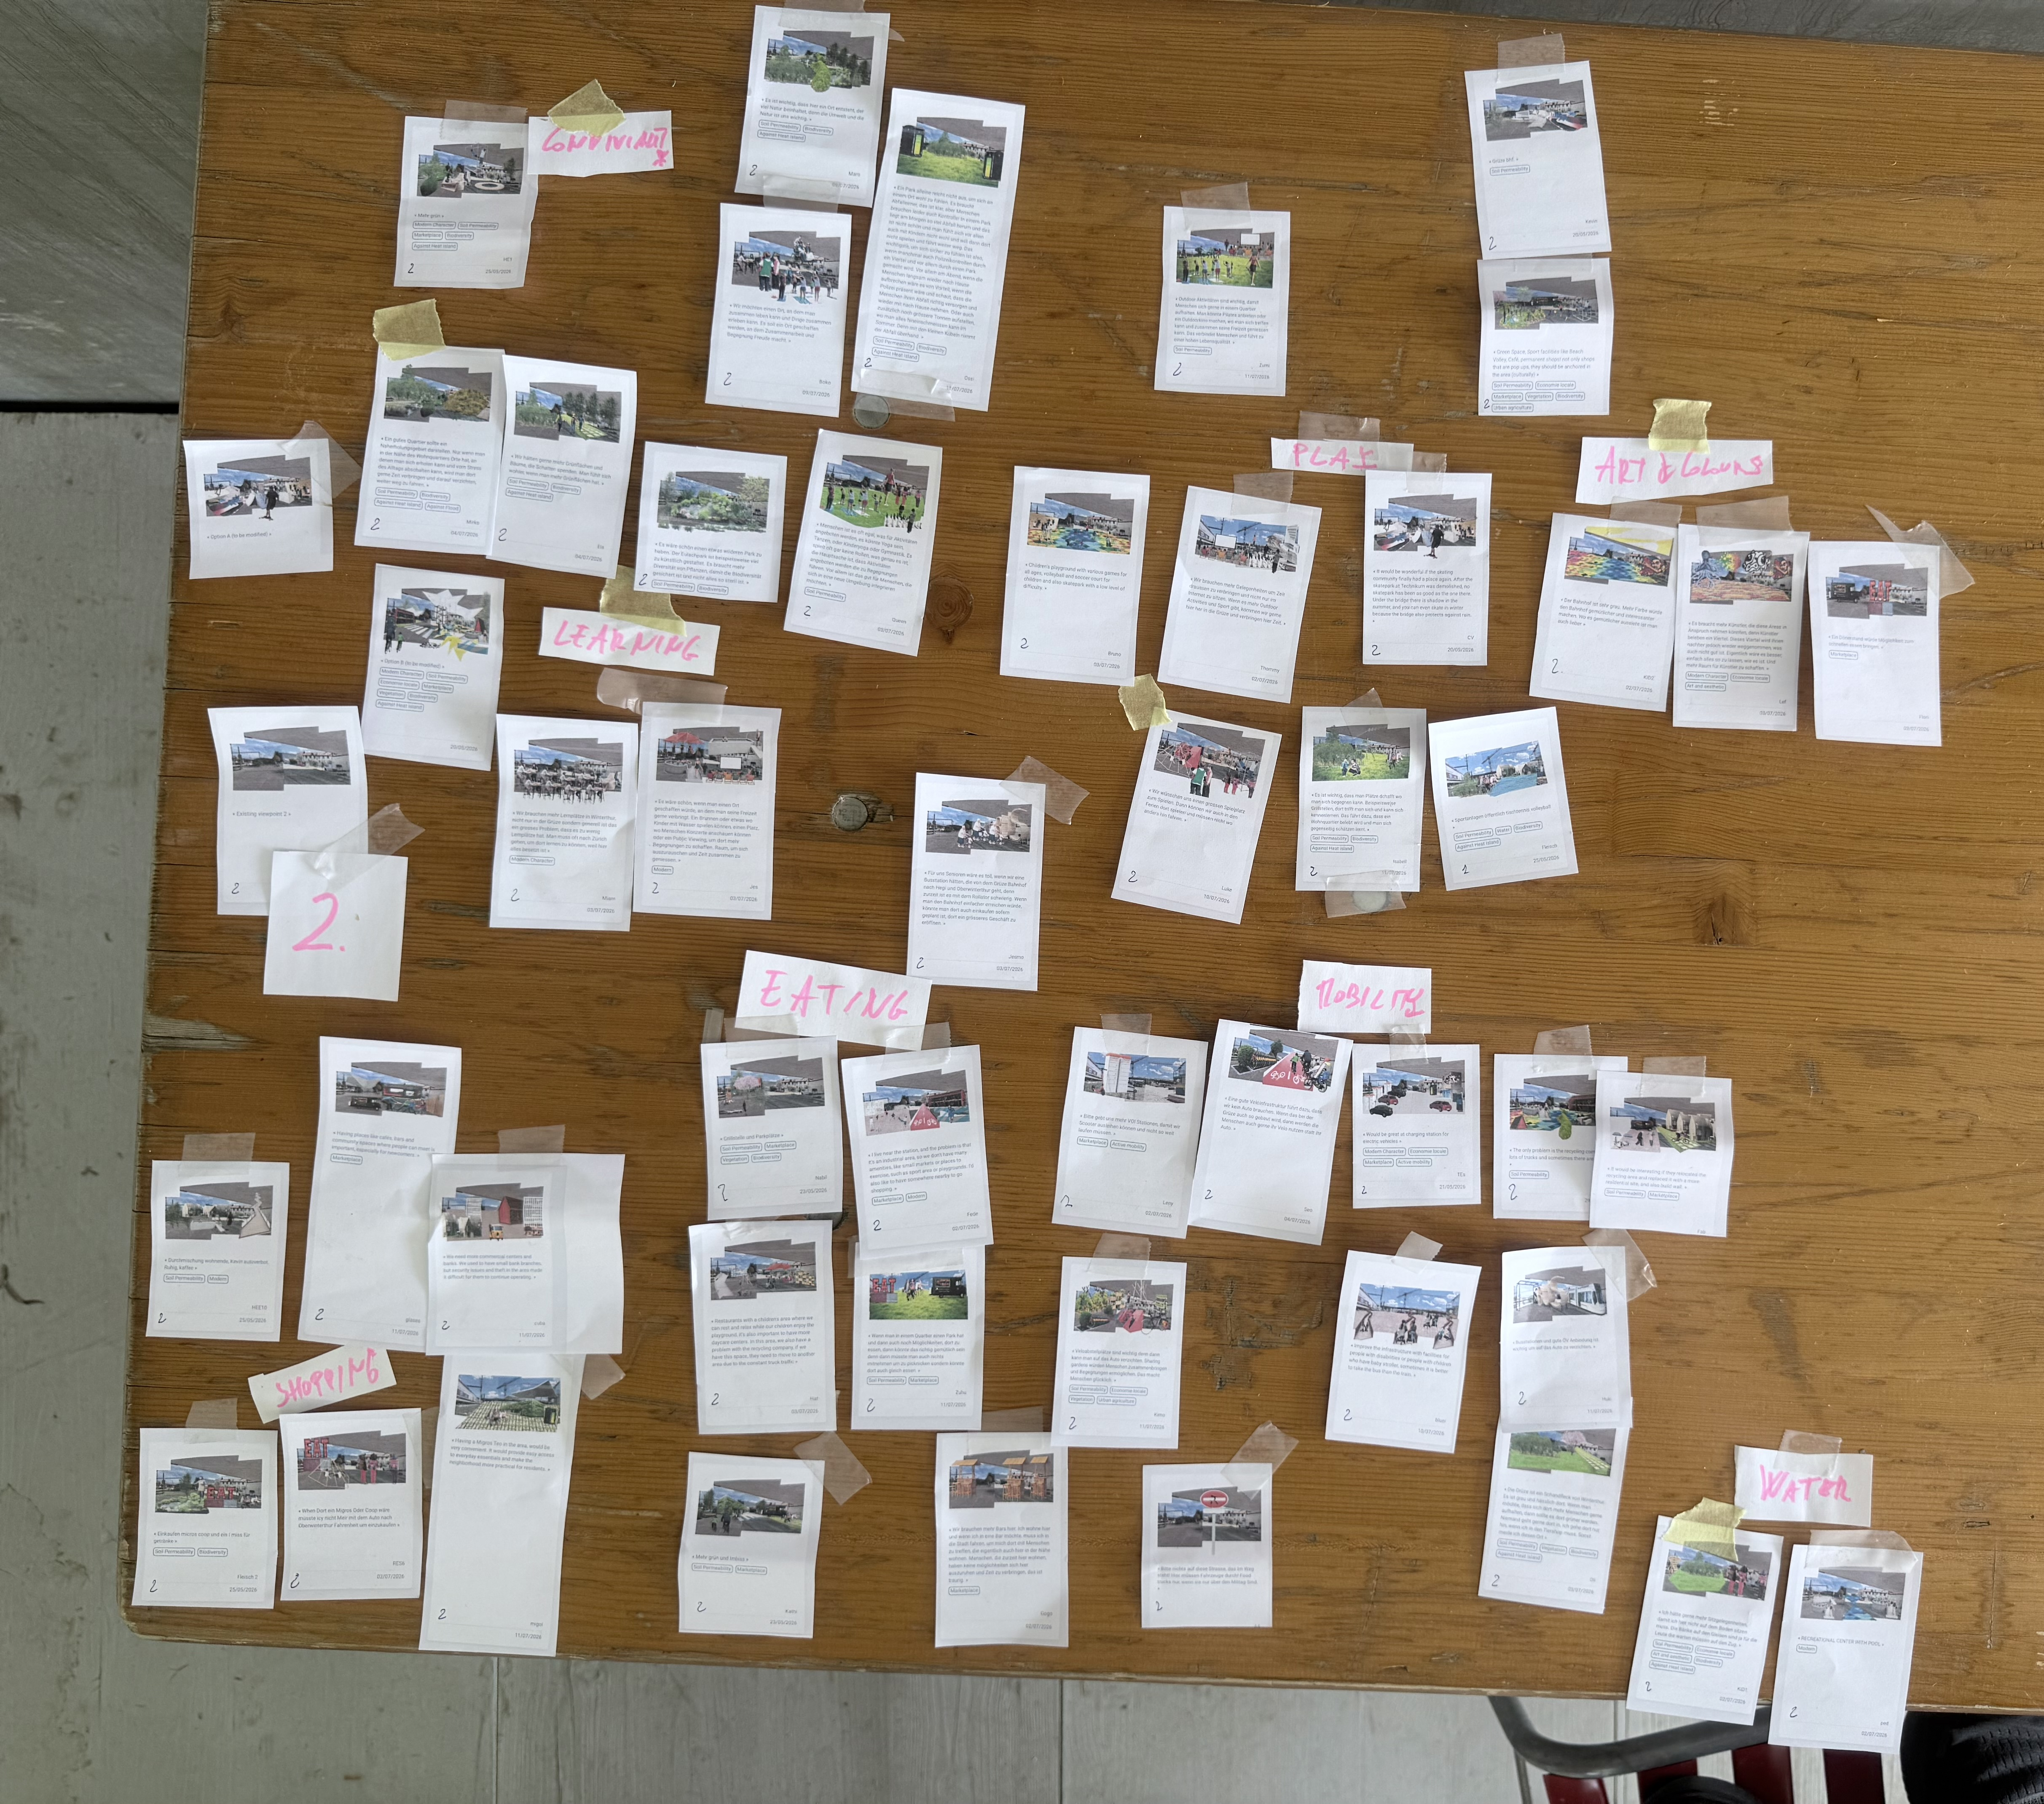
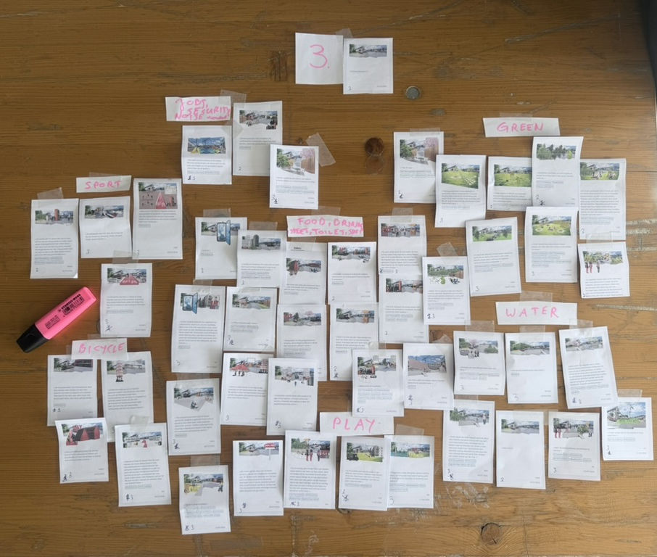
_______________________________________________________________________
_______________________________________________________________________

Innovation Lab (View point 5)

1. Summary
Proposed features for the “Innovation Lab” project, focusing on its design, atmosphere, and planned amenities.

2. Discussion
The team reviewed the concept for the Innovation Lab, which is already perceived as a vibrant “culture hub.” The discussion centered on enhancing this existing atmosphere.
- Target Audience & Core Features:
  - Zoe highlighted that the new developments are primarily aimed at teenagers and young adults.
  - Proposed features to support this include the construction of skate parks and climbing walls to create an artistic and dynamic space.
- Environmental & Ambiance Elements:
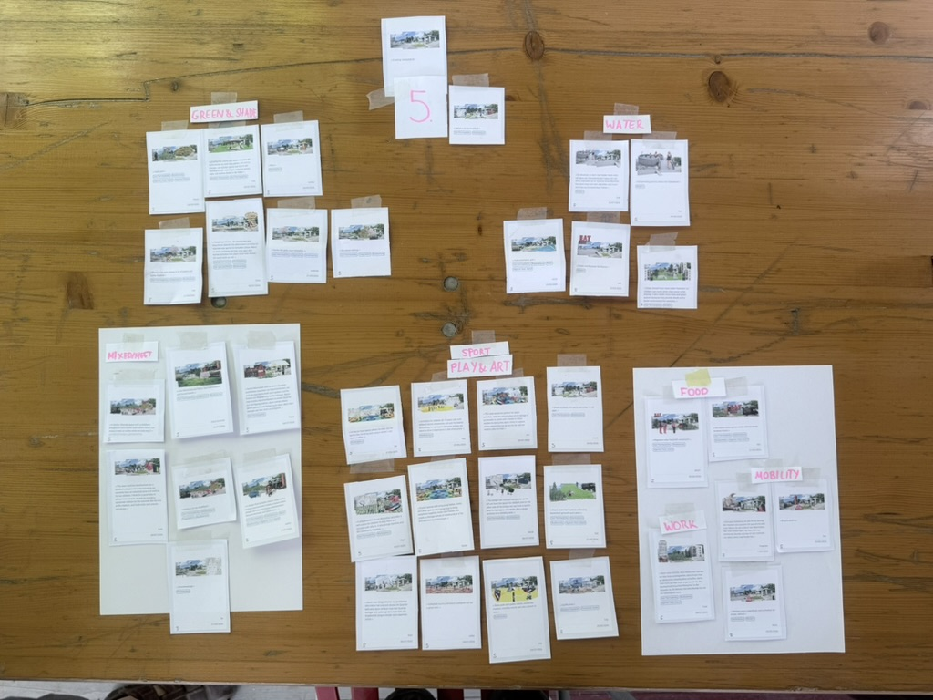
  - Zoe noted that greenery and shaded areas remain a significant topic in the project’s design.
  - The inclusion of water elements, specifically fountains, was identified as a recurring and important theme. This was emphasized by feedback from a recent summer survey conducted during a hot period.
  - Alain confirmed that the desire for water features was also a prominent point raised in earlier contributory workshops, predating the summer survey.
- Commercial & Future Testing:
  - Vicente added that there is a recognized need for small-scale food and commercial activities within the space.
  - Vicente also reported that Martin has expressed interest in using this location as a test site for new concepts.
  - The discussion on the cost for larger elements was deferred to a later time..

_______________________________________________________________________

Near School (View point 6)

1. Summary
Feedback gathered could guide the city planner and architects who will transform the space, themes emerging from contributions.
- Location-Specific Needs:
  - Zoe noted that areas near schools show a high demand for children’s play areas.
  - A general need for water spaces was identified as a response to rising temperatures from climate change.
  - Feedback also indicated the presence of an older population, leading to requests for an accessible and safe environment, including the provision of public toilets.
- Mobility, Safety, and Environment:
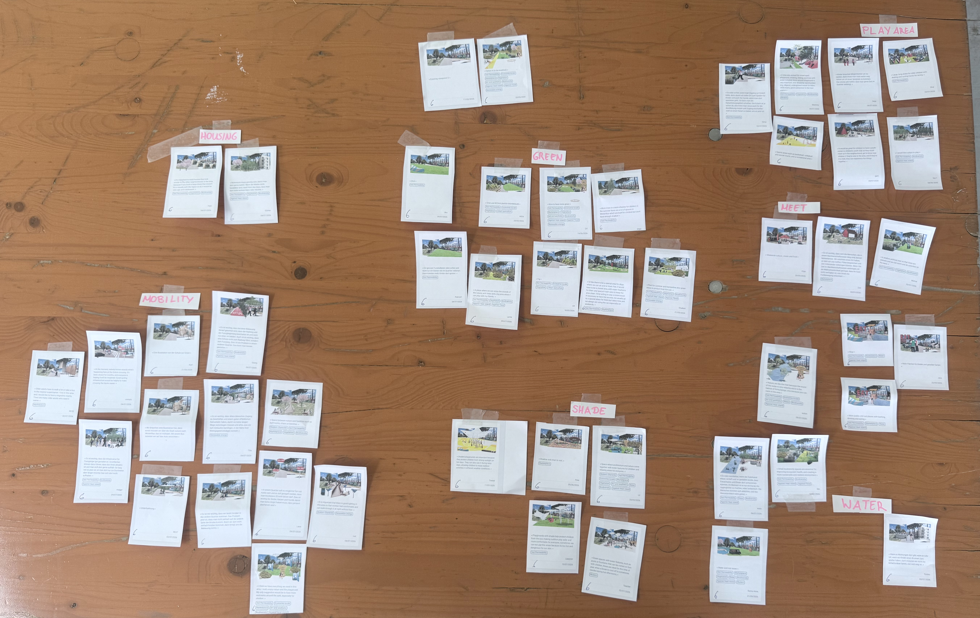
  - Greenery was highlighted by Alain as a consistent and important request from the community.
  - Valentino expanded on the topic of mobility, emphasizing micro-mobility (e.g., walking tracks) and the critical role of lighting for safety. He suggested exploring innovative solutions, such as adaptable or portable lighting.
- Qualitative Insights for Design:
  - Valentino underscored that the community feedback contains valuable qualitative aspects beyond simple requests for activities. He stressed the importance of analyzing underlying qualities such as safety and inclusiveness to provide a richer brief for the architects.
- Housing Requirements:
  - On a larger scale, Zoe mentioned that the feedback also includes a desire for residential housing to be integrated into the area.

_______________________________________________________________________

Project Funding and Implementation Strategy

1. Summary
The meeting focused on defining a strategy for developing and funding community improvement initiatives. The core discussion revolved around shifting from funding standalone “objects” to creating holistic, multi-generational community spaces. Key decisions were made regarding the scope of contributions, budget allocation, and the process for community engagement and voting.

2. Key Discussion Points
Scope of Contributions: Object + Environment
Valentino initiated the discussion by proposing that funding should cover not just a primary object (e.g., a fountain) but also its immediate surroundings. This includes elements like benches, landscaping (e.g., sand), and informational panels to create a more complete and functional space.
The group agreed that this approach is essential for building a true sense of community and attracting diverse groups, including the elderly and families.
Budget and Allocation
A potential budget range of $5,000 to $20,000 per project was discussed.
Valentino provided a sample breakdown for a $20,000 project:
~$12,000 for the main object(s).
~$3,000 for installation and first-year maintenance.
~$5,000 for improving the surrounding environment.
The consensus was to create contributions with similar total costs to ensure the community’s decision is based on preference rather than price.

Community Engagement and Voting
Alain suggested creating two or three distinct contributions to present to the community for a vote. This allows for direct feedback and engagement.
He also proposed a phased implementation, where the winning project is prioritized, but other popular ideas could be developed later, respecting the community’s broader input.

Managing Community Expectations
Zoe raised a critical point about managing expectations. She stressed the need for contributions to clearly distinguish between the specific items that will be funded and implemented versus the conceptual vision for the surrounding area.

She suggested using visual cues, such as making conceptual elements transparent in mock-ups, to prevent creating a “false illusion” and subsequent disappointment.

Next Steps

2. Next steps
  - Decision: The team affirmed that the collected community feedback, with its blend of specific needs and qualitative dimensions, will serve as the foundational brief for the project’s design phase.
  - Task: The project team will compile the analyzed feedback into a comprehensive “panorama” for the urban planners and architects. This brief will detail the community’s requests and qualitative desires (safety, accessibility, etc.) to anchor their creative process.
  - Purpose: To provide architects with a rich, user-centric foundation for the design competition, ensuring their contributions are anchored in the community’s real needs without being restricted by a pre-conceived design.
  - The team confirmed they would first complete the current task of analyzing the idea clusters before developing specific contributions.
  - Future funding contributions will be structured to include both a central feature and improvements to its immediate environment.
  - Contributions will be built around existing or planned anchors (e.g., a restaurant or paddle court) to ensure they complement the area effectively.
  - The team will develop a set of distinct project alternatives, each with a comparable budget (approximately $20,000), to present for a community vote.
  - The winning proposal will be implemented first, with consideration given to other contributions for future development.

_______________________________________________________________________
_______________________________________________________________________

